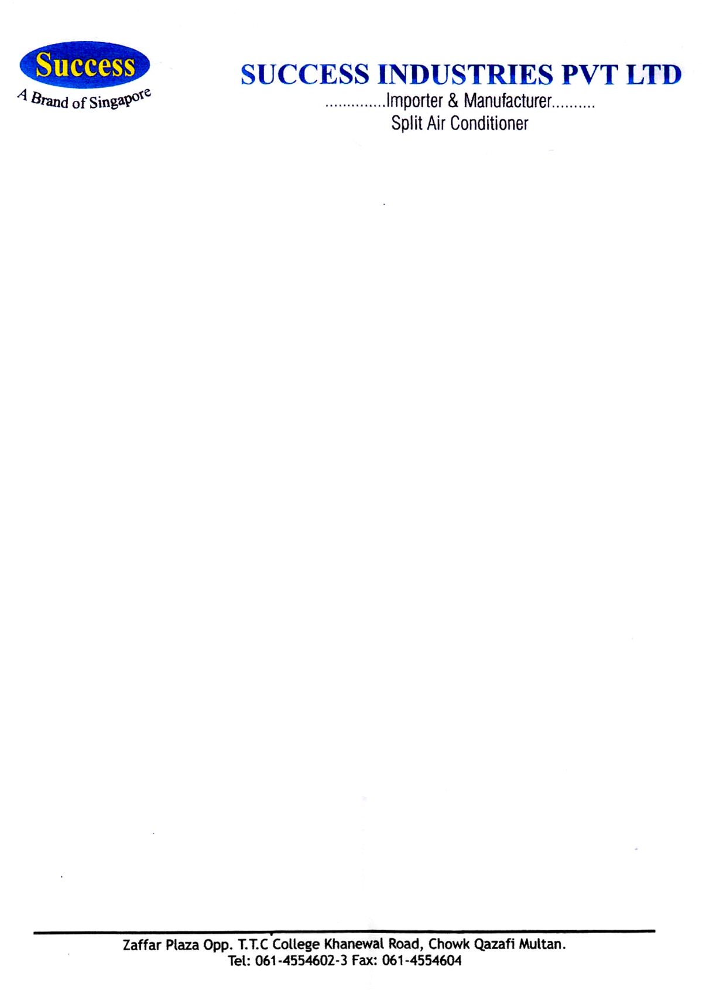

Dated: <To2>

TO WHOM IT MAY CONCERN

It is hereby certify that Mr. <Name> S/O <fname> Having CNIC# <CNIC> has been worked with us as “<Designation>” from <From2> to <To2>.

During his work with us we found him very punctual, submissive and hardworking. We wish him best of luck in his professional career.

Manager Admin

Success Industries (Pvt.) Limited